Technoprobe (TPRO)
Category: Test Equipment (Consumable)
Est. Price Per Unit: $50k - $100k+ per card (AI cards significantly more expensive)

What They Do

Product 101 and Where They Fit into the AI Stack
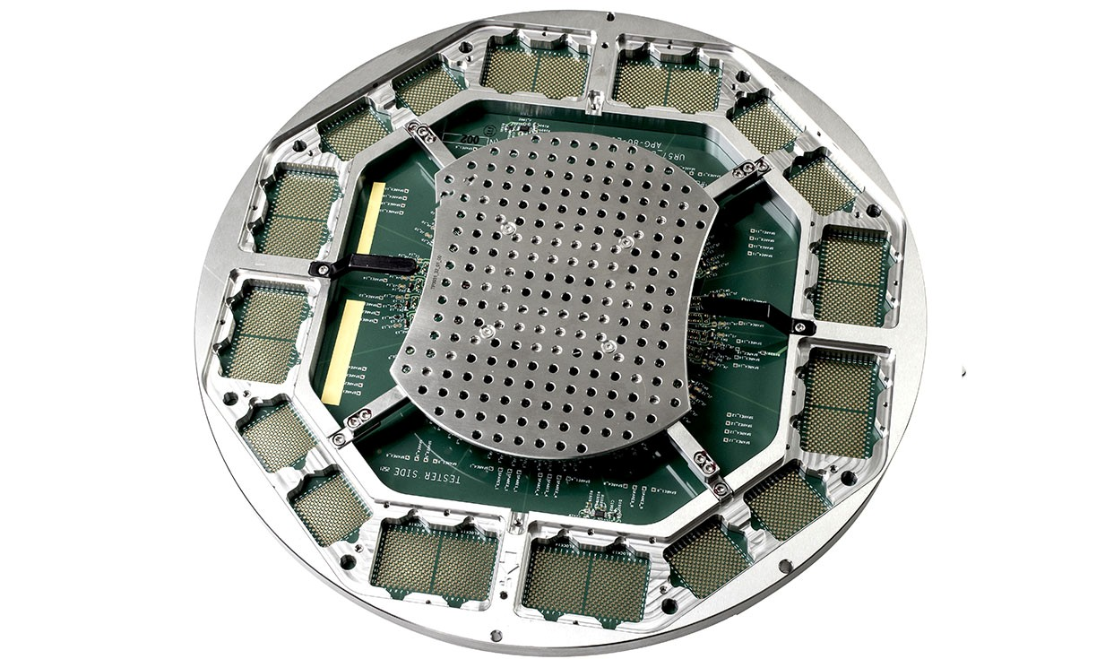
Technoprobe manufactures probe cards—consumable interfaces required to test chips (CPUs, GPUs, AI accelerators)
before they are packaged.
Before a chip goes into a plastic case and gets soldered into a phone or server, it must be tested. If you package a broken chip, you waste money on packaging and risk shipping a dud. The problem is that silicon wafers have millions of microscopic contact points, and the testing machine (ATE) is too clumsy to touch them directly.
A probe card is a round circuit board with thousands of microscopic MEMS needles in the center. These needles physically prick the wafer to create an electrical loop for testing.
Every time Nvidia or Apple designs a new chip, the contact point layout changes. They must buy a new custom probe card.

Alignment with Overall Thesis
AI chips are massive and require probe cards with tens of thousands of pins. These cards cost $100k+ vs. standard cards at $50k.
Chiplets and advanced packaging (CoWoS, SoIC) require Known Good Die testing—you can't stack chips without verifying each layer works. One bad layer ruins the whole stack. This drives 100% testing coverage and higher probe card volume.
Technoprobe specialises in logic (processors), not memory. Directly aligned with AI accelerator growth.

Business Model, Customers
$50k-$100k+ per card. AI/advanced logic at the high end.
Unlike ATE machines (Teradyne), which are one-time capex, probe cards are consumables. Volume driven (more chips = more wear = more replacement) and design driven (new chip = new card).

Comments on Team
Family led, Italian. Founded in 1995 by Giuseppe Crippa in a garage. Family still owns controlling stake.
Co-founder was CEO until 2017 (age 82) and passed in 2025.
Current CEO is founder's nephew; Chairman and Vice Chairman are founder's sons.
Engineering-first, secretive, agile. Known for being technically superior in vertical probe cards (the type needed for highend logic).

Early View of Moat Hypothesis
Design lock-in: every new chip needs a new probe card. Once you're the incumbent, switching mid-production is painful.
Technical leadership in vertical probes—decades of precision engineering investment.
Family structure allows faster iteration than publicly traded American competitors.

Why They're Interesting, and Why Now
AI chips are bigger and more complex = more pins, more testing, higher-value cards. We have to believe AI chip production scales—if it does, Technoprobe is a direct beneficiary.
Chiplets increase the need for Known Good Die testing. You can't stack without verifying.
Unlike one-time capex equipment, probe cards are consumables that scale with production volume. More recurring dynamics.

Key Risks
Customer concentration. If one of the Giants shifts to FormFactor, it hurts.
Tech disruption: if chip designs move to wafer-level burn-in or self-testing architectures, probe card TAM shrinks.
Family governance can be a strength (long-term thinking) or weakness (succession, capital allocation).

Gaps in Understanding / Key Questions
How defensible is the technical lead vs. FormFactor? Winning on tech or relationships/price?
Actual customer concentration breakdown—is it 50% TSMC or more diversified?
Succession planning—how deep is the bench beyond the Crippa family?

Select Financial Graphs

R1: Total Revenue & YoY Growth
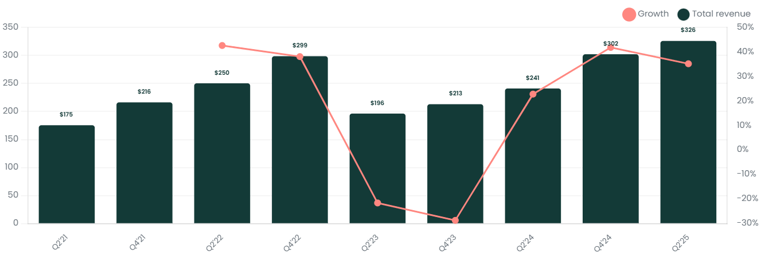

I1: Inventory Turns
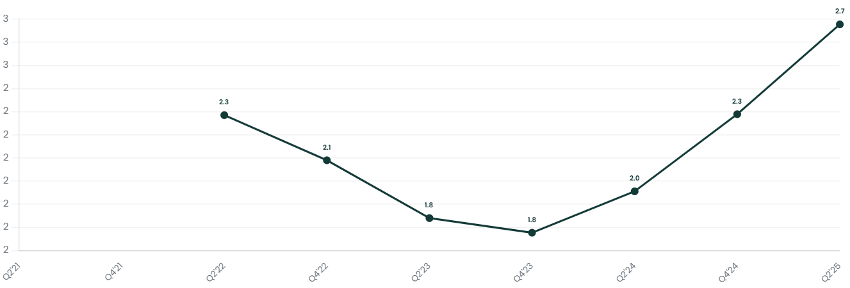

P2: Gross Margin
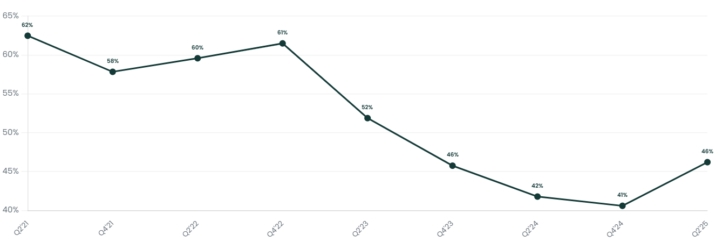

P4: EBIT Margin
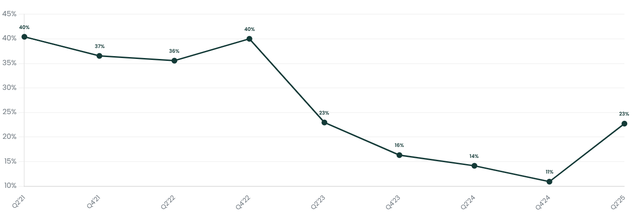

CF2: FCF Margin
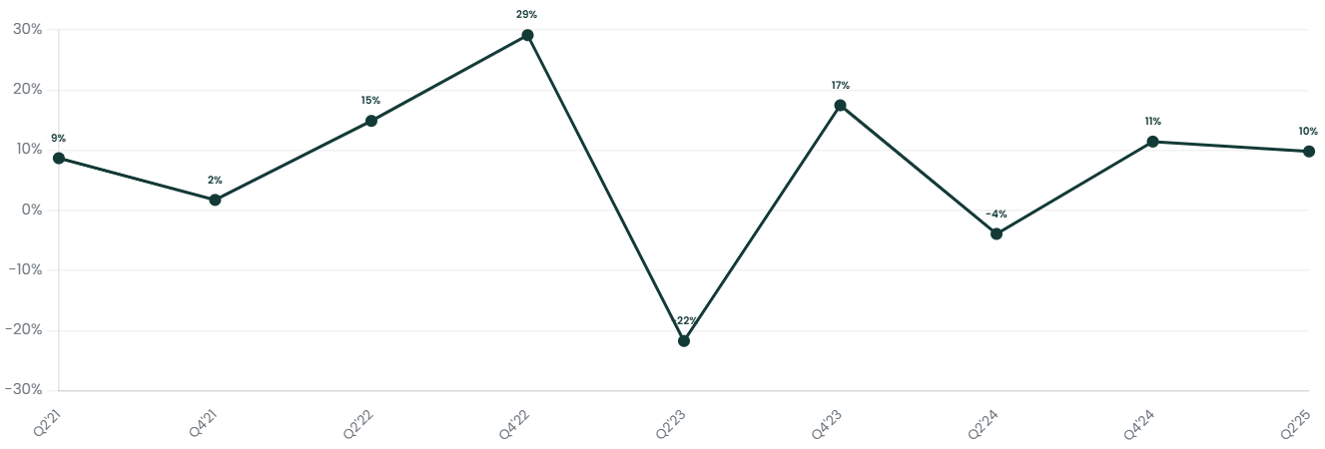

V1: EV/Sales NTM
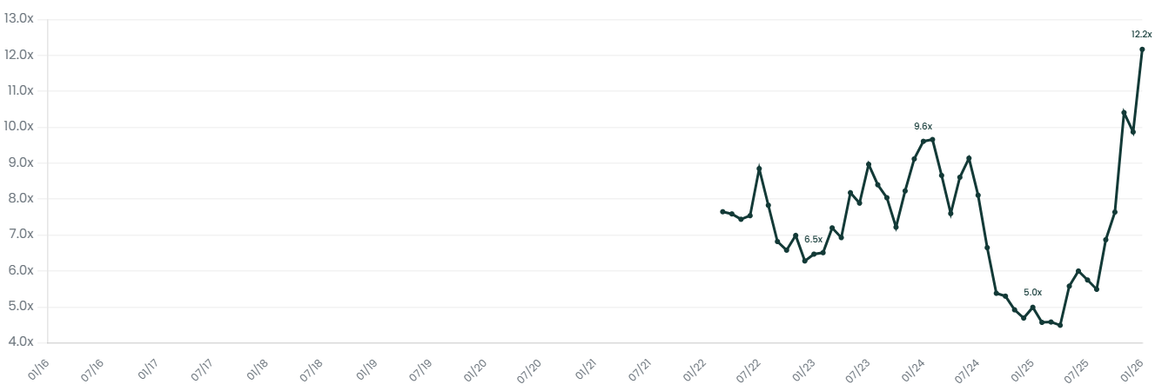

Interesting Topics to Read
Probe cards vs. ATE (Teradyne, Advantest)
Vertical Probe Cards vs. Cantilever technology
Known Good Die (KGD) testing for chiplets
FormFactor competitive positioning
MEMS probe technology

